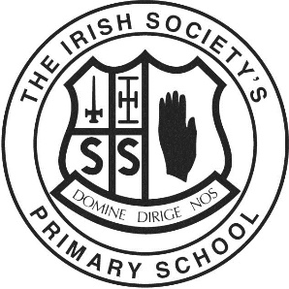
The Irish Society’s Primary School & Nursery Unit

HOLIDAYS 2024-2025

TERM 1  (AUTUMN) | Term starts Thursday 29th August 2024 (finish at 12.00pm)
Half-term | School closes Friday 25th October at 3.00pm  Re-opens Monday 4th November
Christmas | School closes 12.00pm Friday 20th December
TERM 2  (SPRING) | School re-opens Monday 6th January 2025
Half-term | School closes Friday 7th February at 3.00pm and  re-opens Monday 17th February
Holiday | Monday 17th March
Easter | School closes at 12.00pm on Friday 11th April
TERM 3  (SUMMER) | School re-opens Monday 28th April
Bank Holiday | Monday 5th May
Holiday | Monday 26th May
End of Year | Schools closes Monday 30th June at 12.00pm

